INTERNSHIP PROJECT REPORT
ON
Secure File Transfer Monitoring System
Submitted as part of the Cyber Security Internship Program

Internship Period
December 2025 – June 2026

Supervised By: Submitted By:
Mr. Harshit Ravi
Organization:
Unified Mentor

INDEX

Sr. No. | Title | Page No.
1. | Abstract | 4
2. | Introduction | 5-6
3. | Problem Statement | 7
4. | Project Objective | 8
5. | Scope of the Project  - 5.1 In Scope  - 5.2 Out of Scope | 9
6. | Tools & Technologies Used | 10
7. | Methodology / Workflow | 11-13
8. | Implementation Details | 14-17
9. | Results & Findings | 18
10. | Security Recommendations | 19
11. | Learning Outcomes | 20
12. | Conclusion | 21
13. | Future Enhancements | 22
14. | References | 23

List of Figures

Figure No. | Description | Page No.
Figure 7.1 | Workflow Diagram | 13
Figure 8.1 | System Start | 14
Figure 8.2 | File Event Detection | 15
Figure 8.3 | Normal Activity Log | 15
Figure 8.4 | Hash Generation & Authorization Check | 16
Figure 8.5 | Unauthorized Access Detection Alert | 16
Figure 8.6 | Log File | 17
Figure 8.7 | Final Report | 17

1. ABSTRACT
The Secure File Transfer Monitoring System is a cybersecurity-based project developed to monitor, analyze, and secure file-related activities within a computer system. In modern digital environments, file transfers such as copying, moving, modifying, and deleting files are very common operations. However, these activities can introduce serious security risks, including unauthorized access, data leakage, insider threats, and malicious file tampering. Therefore, it becomes essential to implement a monitoring mechanism that can track such activities in real time and ensure the protection of sensitive information.
This project aims to design and implement a system that continuously observes file system events and records all file operations performed within a specified directory. The system is capable of detecting file creation, modification, deletion, and movement. Each event is logged with detailed information such as timestamp, file path, and type of operation. This logging mechanism helps in maintaining a complete audit trail of all file activities, which can be used for security analysis and forensic investigations.
A key feature of this system is the identification and monitoring of sensitive files. The system maintains a predefined list of critical or confidential files, and any activity involving these files is treated as high priority. Whenever a sensitive file is modified, deleted, or moved, the system generates an alert, allowing users or administrators to take immediate action. This helps in preventing unauthorized access and potential data exfiltration.To ensure data integrity, the system incorporates a hashing mechanism using the SHA-256 algorithm. Whenever a file is modified, a hash value is generated and recorded. If the file content changes, the hash value also changes, enabling the system to detect any tampering or corruption.
The system also provides a simple yet effective alerting mechanism and maintains logs that can be used to generate reports. These reports help in understanding system behavior, identifying suspicious patterns, and improving overall security posture. The implementation of this project provides practical knowledge of important cybersecurity concepts such as file system monitoring, data loss prevention (DLP), and integrity verification techniques.
Overall, the Secure File Transfer Monitoring System offers an efficient and practical solution for tracking file activities, detecting unauthorized actions, and ensuring the security of sensitive data. It reflects real-world security practices used in organizations, making it a valuable learning experience in the field of cybersecurity and system monitoring.
2. INTRODUCTION
In today’s digital era, the importance of data security has increased significantly due to the rapid growth of information technology and the widespread use of computer systems. Organizations and individuals rely heavily on digital data for communication, storage, and processing of information. File transfers such as copying, moving, modifying, and deleting data are routine operations performed on a daily basis. However, these activities can also become potential sources of security vulnerabilities if not properly monitored and controlled.
One of the major concerns in modern cybersecurity is the unauthorized movement of sensitive data. Data leakage, insider threats, and unauthorized access are among the most common risks faced by organizations. Employees or malicious users may intentionally or unintentionally transfer confidential files outside the system, leading to serious consequences such as financial loss, privacy breaches, and reputational damage. Additionally, malware and other malicious programs can modify or corrupt files, making it difficult to maintain data integrity.
To address these challenges, it is essential to implement systems that can monitor file activities in real time and detect suspicious behavior. A Secure File Transfer Monitoring System is one such solution that provides continuous tracking of file operations within a system. It helps in identifying unauthorized file transfers, monitoring sensitive data movement, and ensuring that file integrity is maintained. By analyzing file system events, the system can provide valuable insights into how files are being accessed and modified.
The proposed system focuses on monitoring a specific directory or set of directories and capturing all file-related events such as file creation, modification, deletion, and movement. Each event is recorded along with relevant details including timestamp, file path, and type of operation. This information is stored in log files, which can later be used for auditing and analysis. Logging plays a crucial role in cybersecurity as it helps in tracing user activities and identifying suspicious patterns.
Another important aspect of the system is the identification of sensitive files. Certain files contain critical or confidential information and require special protection. The system maintains a list of such sensitive files and continuously monitors them for any changes. If a sensitive file is accessed, modified, deleted, or moved without authorization, the system generates an alert. This alert mechanism enables quick response and helps in preventing potential data breaches.
In addition to monitoring and alerting, the system also ensures data integrity through the use of cryptographic hashing techniques. The SHA-256 hashing algorithm is used to generate a unique hash value for each file. Whenever a file is modified, a new hash value is calculated and compared with the previous value. If there is a mismatch, it indicates that the file has been altered. This process helps in detecting unauthorized modifications and ensures that the data remains consistent and reliable.
The development of this project provides practical exposure to various cybersecurity concepts and techniques. It introduces the concept of file system monitoring, which is widely used in intrusion detection systems and security tools. It also demonstrates the use of hashing algorithms for integrity verification, which is a fundamental aspect of data security. Furthermore, the project highlights the importance of logging and auditing in maintaining system security and accountability.
This system can be implemented in various environments, including personal computers, organizational networks, and enterprise systems. It can be used as a basic security tool for monitoring file activities and preventing unauthorized data transfers. Although the current implementation focuses on a single system, the concept can be extended to network-level monitoring and integrated with advanced security solutions such as Security Information and Event Management (SIEM) systems.
In conclusion, the Secure File Transfer Monitoring System provides an effective approach to enhancing data security by monitoring file activities, detecting unauthorized actions, and ensuring data integrity. It serves as a practical example of how security mechanisms can be implemented to protect sensitive information and prevent potential threats. This project not only addresses real-world security challenges but also contributes to the development of essential skills in the field of cybersecurity.
Furthermore, the system plays an important role in enhancing organizational security policies by providing continuous monitoring and early detection of suspicious activities. It reduces the risk of data loss by identifying abnormal file behavior at an early stage. The project also helps in building a proactive security approach rather than a reactive one. With increasing cyber threats, such monitoring systems are becoming essential components of modern security infrastructure. This project, therefore, not only focuses on technical implementation but also emphasizes the importance of preventive cybersecurity measures.

3. PROBLEM STATEMENT
In modern computing environments, file operations such as copying, moving, modifying, and deleting files are performed frequently by users and applications. While these operations are essential for daily tasks, they also introduce significant security risks when not properly monitored. One of the major challenges faced by organizations and individuals is the lack of visibility and control over file transfer activities within a system.
Sensitive data stored in files can be easily accessed, modified, or transferred without proper authorization. This can lead to serious issues such as data leakage, insider threats, unauthorized sharing of confidential information, and loss of critical data. For example, an employee may copy important organizational data to an external storage device, or malicious software may alter system files without detection. In many cases, such activities go unnoticed due to the absence of an effective monitoring system.
Another critical problem is the lack of data integrity verification. When files are modified, it becomes difficult to determine whether the changes are legitimate or malicious. Without proper integrity checks, organizations cannot ensure the reliability and authenticity of their data. This increases the risk of data corruption, tampering, and unauthorized modifications.
Additionally, most systems do not provide real-time alerts for suspicious file activities. As a result, security breaches are often detected only after damage has already occurred. The absence of proper logging and auditing mechanisms further complicates the process of identifying the source of a security incident and performing forensic analysis.
Therefore, there is a need for a system that can continuously monitor file system activities, detect unauthorized access or movement of sensitive files, verify file integrity, and generate alerts for suspicious behavior. Such a system should maintain detailed logs of all file operations and provide a mechanism for analyzing and reporting potential security threats.
The Secure File Transfer Monitoring System is proposed as a solution to these problems. It aims to provide real-time monitoring, alerting, and logging capabilities to enhance data security, prevent unauthorized file transfers, and ensure the integrity of sensitive information within a system.

4. PROJECT OBJECTIVES
The primary objective of the Secure File Transfer Monitoring System is to design and implement a security solution that continuously monitors file-related activities within a system and ensures the protection of sensitive data. With the increasing risk of data breaches and unauthorized file transfers, it becomes essential to develop a system that can detect, analyze, and respond to suspicious file operations in real time.
One of the key objectives of this project is to monitor all file system events, including file creation, modification, deletion, and movement. By tracking these activities, the system provides complete visibility into how files are being accessed and manipulated within the monitored directory. This helps in identifying abnormal behavior and potential security threats.
Another important objective is to detect unauthorized access or movement of sensitive files. The system maintains a predefined list of critical files, and any activity involving these files is treated as high priority. If a sensitive file is modified, deleted, or moved, the system generates an alert to notify the user or administrator. This enables quick action to prevent data leakage or misuse.
The project also aims to implement file integrity verification using cryptographic hashing techniques, specifically the SHA-256 algorithm. By generating and comparing hash values of files before and after modification, the system can detect any changes in file content. This ensures that the data remains consistent and helps in identifying tampering or corruption.
In addition to monitoring and detection, another objective is to maintain detailed logs of all file activities. These logs include important information such as timestamps, file paths, and types of operations performed. The logging mechanism serves as an audit trail that can be used for security analysis, incident investigation, and forensic purposes.
Furthermore, the system is designed to generate alerts for suspicious or unauthorized actions. The alert mechanism helps in real-time detection of potential threats and reduces the response time in case of security incidents.
Finally, the project aims to provide practical exposure to cybersecurity concepts such as file system monitoring, data loss prevention, and integrity verification. It helps in understanding how real-world security systems operate and how monitoring tools can be used to protect sensitive information. The overall goal is to develop a simple, efficient, and effective monitoring system that enhances data security and supports secure file management practices.
5. SCOPE OF THE PROJECT
The Secure File Transfer Monitoring System is designed to monitor and analyze file-related activities within a local system. The main scope of the project is to provide real-time tracking of file operations and ensure the security of sensitive data. The system focuses on detecting unauthorized file access, modification, deletion, and movement within a specified directory. It helps in improving data security by maintaining logs and generating alerts for suspicious activities.
5.1 In-Scope
The following functionalities are included in this project:
- Monitoring file events such as creation, modification, deletion, and movement.
- Tracking activities within a user-defined folder or directory.
- Identifying and monitoring sensitive files.
- Generating alerts for unauthorized access or changes in sensitive files.
- Using SHA-256 hashing to verify file integrity.
- Maintaining logs with timestamps and file details.
5.2 Out-of-Scope
The following functionalities are not included:
- Monitoring across networks or multiple systems.
- Integration with advanced security systems like SIEM.
- Email or SMS-based alert notifications.
- User authentication and access control.
- Cloud storage monitoring.
- Graphical User Interface (GUI).
- Automated threat response mechanisms.

6. Tools & Technologies Used
The following tools and technologies are used in the development of the Secure File Transfer Monitoring System:
- Programming Language: Python is used as the main programming language due to its simplicity, readability, and strong support in cybersecurity applications. It allows easy implementation of file monitoring, hashing, and logging functionalities.
- File Monitoring Library: The Watchdog library is used for real-time file system monitoring. It detects events such as file creation, modification, deletion, and movement, helping in continuous tracking of file activities within a directory.
- Hashing Technique: The Hashlib library is used to generate file hash values using the SHA-256 algorithm. This helps in verifying data integrity and detecting any unauthorized changes in file content.
- Time Management: The Time module is used to generate timestamps for each file event. It records the exact time of operations, which is useful for tracking and log analysis.
- Logging System: A simple text-based logging mechanism is implemented to store file activity details such as file path, event type, and timestamp. It acts as an audit trail for monitoring and investigation purposes.
- Development Environment: Visual Studio Code is used as the code editor. It provides debugging tools and extensions that simplify Python development and improve coding efficiency.
- Operating System: Windows OS is used for implementation and testing. It provides the required environment for running Python scripts and performing file monitoring operations.
Overall, these tools and technologies work together to create an efficient, reliable, and secure file monitoring system that supports real-time tracking and data protection. The combination of these tools ensures smooth performance, accurate monitoring, and effective handling of file-related events. This setup also provides a strong foundation for future enhancements and integration with advanced security systems.

7. Workflow / Architecture
The Secure File Transfer Monitoring System follows a well-defined workflow to monitor, detect, and log file-related activities in real time. The architecture is designed in a modular manner, where each component performs a specific function. This structured design ensures efficient monitoring, better performance, and easy understanding of the system. The workflow focuses on capturing file events, analyzing them, and maintaining proper records to enhance data security.
1. Directory Selection
The workflow begins with the selection of a directory that needs to be monitored. This directory acts as the target location where all file-related activities are tracked. The system can also monitor subdirectories, ensuring that no file operation goes unnoticed. This step helps in focusing the monitoring process on relevant data.
2. System Initialization
In this stage, the system initializes all required components and libraries such as Watchdog, Hashlib, and Time. Configuration settings like the list of sensitive files and the log file path are defined. This step ensures that the system is properly set up before starting the monitoring process.
3. Observer Setup
The Watchdog Observer is initialized and linked to the selected directory. It continuously listens for file system changes and operates in the background. The observer ensures that all file activities are captured in real time without affecting system performance.
4. Event Detection
The system detects various types of file events such as creation, modification, deletion, and movement. Each event is captured immediately as it occurs. This real-time detection allows the system to track all activities accurately and efficiently.
5. Event Handling
Once an event is detected, it is passed to the event handler module. The handler identifies the type of event and extracts relevant details such as file path and operation performed. It then prepares this information for further processing and analysis.
6. Hash Generation
When a file is modified, the system generates a hash value using the SHA-256 algorithm. This hash acts as a unique fingerprint of the file. Any change in the file content results in a different hash value, which helps in detecting unauthorized modifications or tampering.
7. Sensitive File Verification
The system checks whether the affected file is included in the predefined list of sensitive files. These files are considered critical and require special monitoring. This step ensures that important data is given higher priority in terms of security.
8. Alert Generation
If a sensitive file is modified, deleted, or moved, the system generates an alert. The activity is marked as suspicious, indicating a potential security threat. This helps in early detection and allows quick action to prevent data loss or misuse.
9. Logging Mechanism
All file-related events are recorded in a log file. The log includes important details such as timestamp, file path, and type of operation performed. This logging mechanism creates an audit trail that can be used for monitoring, analysis, and forensic investigation.
10. Continuous Monitoring
The system runs continuously in a loop, ensuring uninterrupted monitoring of file activities. It keeps tracking changes in real time and only stops when manually terminated. This ensures constant protection and visibility of file operations.
Architecture Overview
The architecture of the system consists of five main components: User Input Module, Monitoring Module, Processing Module, Security Module, and Logging Module. The User Input Module is responsible for providing the directory path and sensitive file list. The Monitoring Module continuously tracks file events using the observer. The Processing Module handles detected events and prepares them for analysis. The Security Module performs hashing and verifies sensitive files to detect threats. Finally, the Logging Module records all activities for future reference.

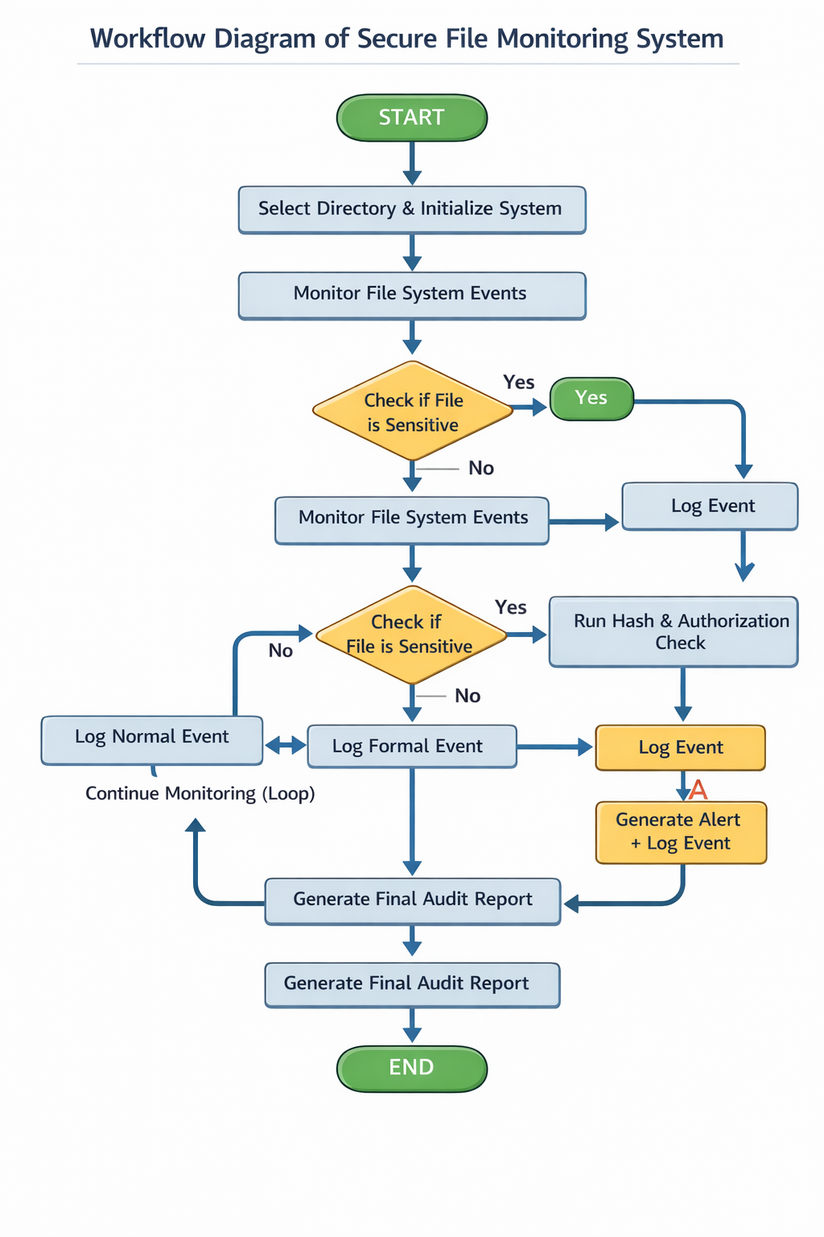

Fig-7.1 Workflow Diagram
8.Implementation Details
- Development Environment: The Secure File Monitoring System is developed using modern programming tools and libraries to ensure real-time monitoring and efficient performance.
- Programming Language: Python 3.12
- Libraries Used:
watchdog – for real-time file system monitoring
hashlib – for generating file hash values
os – for file and directory operations
- Platform: Windows
- Development Tools: Visual Studio Code
These technologies enable the system to monitor file activities efficiently and detect unauthorized changes.
- System Initialization: The system begins by selecting a target directory that needs to be monitored. Once the directory is specified, the monitoring process is initialized. The system continuously runs in the background and waits for file-related events such as creation, modification, or deletion.
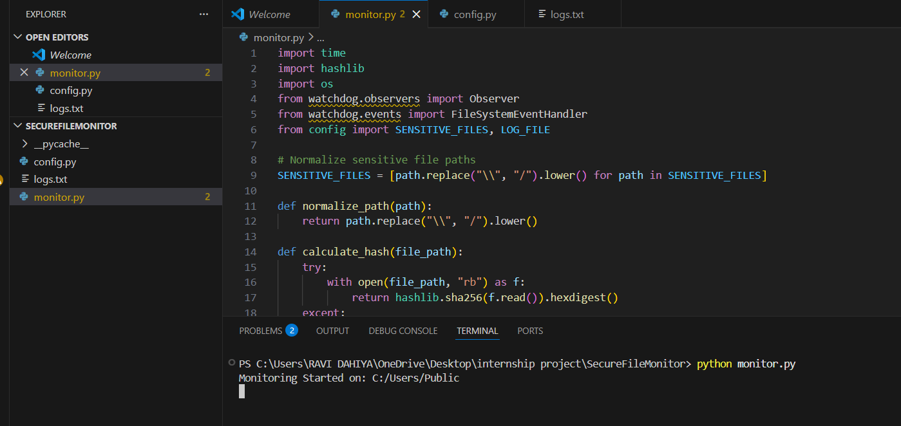
Fig 8.1: System Start
- File Monitoring Mechanism: The system uses the watchdog observer to track file system events in real-time. Whenever an event occurs, the system captures: File name, File path, Type of operation (create, modify, delete). This mechanism ensures continuous surveillance of all activities inside the monitored directory.
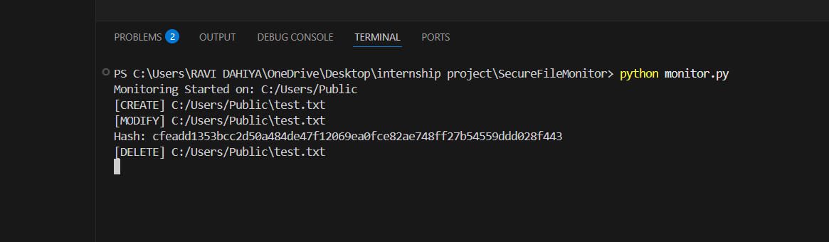
Fig 8.2: File Event Detection

- Sensitive File Detection: After detecting a file event, the system checks whether the file is sensitive or not. Sensitive files may include: .txt, .pdf, .docx, or predefined important files. If the file is not sensitive: The system logs it as a normal activity. If the file is sensitive: The system proceeds to perform security checks
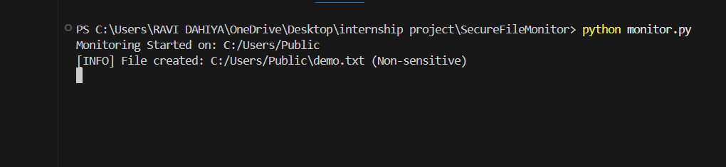
Fig 8.3: Normal Activity Log

- Hash Generation and Authorization Check: For sensitive files, the system generates a unique hash value using the hashlib library. This hash helps in:
- Verifying file integrity
- Detecting unauthorized modifications
The system then checks whether the file movement or modification is authorized.
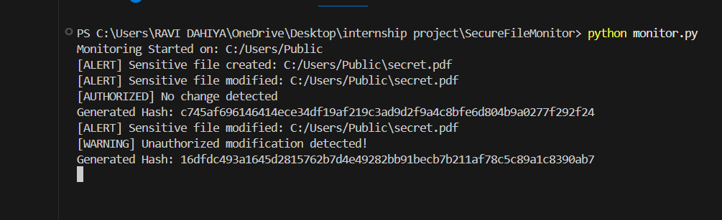
Fig 8.4: Hash Generation and Authorization check
- Unauthorized Access Detection: If the system detects that the file activity is unauthorized, it immediately triggers an alert. Actions performed:
- Generate alert message
- Mark event as suspicious
- Store it in logs
This feature helps in identifying potential cyber threats or data breaches.
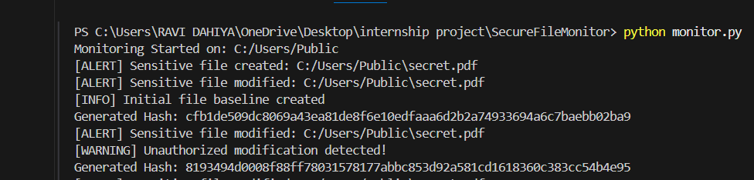
Fig 8.5: Unauthorized Access Detection Alert

- Logging System: All events are recorded in a log file for future analysis and auditing. The log file contains: File name, Timestamp, Action performed, Status (Normal / Alert). This ensures proper tracking and accountability of all file activities.
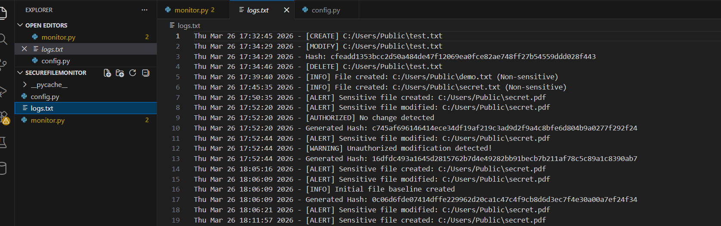
Fig 8.6: Log File
- Audit Report Generation: At the end of monitoring, the system generates a final audit report. The report includes:
- Total number of events
- Number of alerts generated
- Summary of activities
This report is useful for security analysis and decision-making.
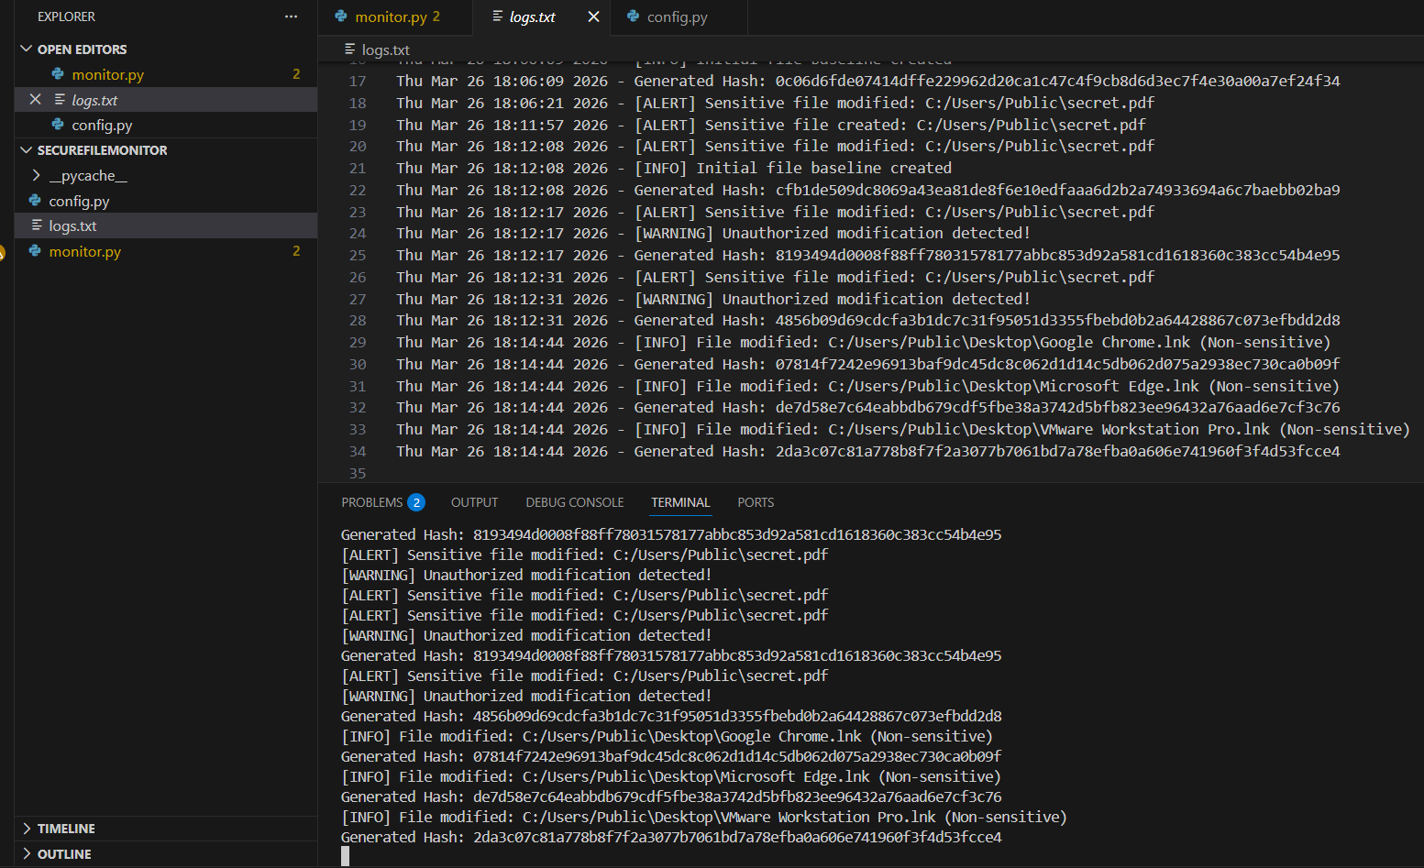
Fig 8.7: Final Report
9. Results and Findings
The Secure File Monitoring System was successfully implemented and tested in a real-time environment to evaluate its performance in detecting file-related activities and potential unauthorized access. The system continuously monitored a specified directory and generated alerts based on file operations such as creation, modification, deletion, and movement.
During testing, the system accurately detected the creation of sensitive files such as PDF and DOCX formats. Whenever a new sensitive file was created, the system immediately generated an alert message, confirming its ability to identify important files effectively. This ensures that critical data is always under surveillance.
The modification detection feature worked efficiently by calculating the hash value of the file. When a file was modified for the first time, the system established a baseline hash value. For subsequent modifications, it compared the new hash with the previously stored hash. If any mismatch was found, the system successfully identified it as an unauthorized modification and generated a warning alert. This demonstrates the system’s capability to detect even minor changes in file content.
The unauthorized access detection mechanism proved to be one of the most important features of the system. It was observed that every unauthorized modification triggered a warning message, indicating a potential security threat. This helps in identifying suspicious activities and possible data breaches in real-time.
Additionally, the logging system worked effectively by recording all events along with timestamps. This provides a complete audit trail, which can be useful for future analysis, investigation, and reporting purposes.
The system also handled multiple events efficiently without generating duplicate alerts, thanks to the debounce mechanism implemented in the code. This improved the overall performance and reduced unnecessary notifications.
Overall, the results indicate that the Secure File Monitoring System is reliable, efficient, and capable of detecting unauthorized file activities. It can be effectively used as a basic cybersecurity tool to monitor sensitive files and protect important data from unauthorized access.

10. Security Recommendations
To improve the effectiveness and reliability of the Secure File Monitoring System, several security recommendations can be implemented. These suggestions aim to enhance system protection, reduce risks, and provide better control over sensitive data.
Firstly, it is recommended to implement a proper user authentication mechanism. Only authorized users should be allowed to access, modify, or manage sensitive files. This can be achieved by integrating login systems or role-based access control (RBAC), ensuring that only permitted individuals can perform critical operations.
Secondly, the system should include real-time notification features such as email alerts or SMS alerts. Whenever an unauthorized modification or suspicious activity is detected, the system should immediately notify the administrator. This will enable quick response and reduce the chances of data breaches.
Another important recommendation is to secure the log files. Since logs contain critical information about file activities, they should be protected from unauthorized access or tampering. This can be done by storing logs in a secure location and applying encryption techniques to maintain their integrity and confidentiality.
It is also advisable to extend the monitoring system to cover more file types and directories. Currently, the system focuses on specific file extensions such as PDF and DOCX. Expanding this to include other sensitive file formats and multiple directories will make the system more robust and comprehensive.
Regular backup of sensitive files is another key recommendation. In case of accidental deletion or malicious activity, backups can help restore important data quickly. Automated backup solutions can be integrated with the system for better reliability.
Additionally, implementing advanced threat detection techniques such as anomaly detection or behavior analysis can further improve the system. This will allow the system to identify unusual patterns and potential cyber threats beyond simple file modifications.
Finally, it is recommended to keep the system updated with the latest security patches and improvements. Regular updates will help in fixing vulnerabilities and ensuring that the system remains secure against new types of attacks.

11. Learning Outcomes
The development of the Secure File Monitoring System provided valuable practical knowledge and hands-on experience in the field of cybersecurity and system monitoring. This project helped in understanding how real-time monitoring systems work and how they can be used to protect sensitive data from unauthorized access.
One of the key learning outcomes was gaining a clear understanding of file system monitoring. By using Python libraries such as watchdog, it became possible to track file activities like creation, modification, deletion, and movement in real time. This enhanced knowledge of how operating systems handle file events and how these events can be captured programmatically.
Another important learning was the concept of hashing for data integrity. The project used SHA-256 hashing to generate unique hash values for files. This helped in understanding how even a small change in file content results in a completely different hash value, making it an effective method for detecting unauthorized modifications.
The implementation of an authorization mechanism provided insight into how systems differentiate between authorized and unauthorized actions. By comparing current and previous hash values, the system was able to detect suspicious changes, which strengthened the understanding of basic intrusion detection techniques.
Additionally, the project improved programming and problem-solving skills. Handling real-time events, managing duplicate triggers, and fixing issues such as encoding errors helped in developing debugging and logical thinking abilities. It also provided experience in writing clean, structured, and efficient code.
The logging feature introduced the concept of maintaining records for auditing and analysis. This highlighted the importance of logs in cybersecurity for tracking activities, identifying threats, and supporting investigations.
Furthermore, this project enhanced knowledge of practical cybersecurity concepts such as data protection, threat detection, and system security. It demonstrated how simple tools can be used to build effective security solutions.
Overall, the project was highly beneficial in bridging the gap between theoretical knowledge and practical implementation, and it provided a strong foundation for future learning and development in cybersecurity.
12. Conclusion
The Secure File Monitoring System was successfully designed and implemented to monitor file activities and detect unauthorized access in real time. The project achieved its primary objective of providing a simple yet effective solution for protecting sensitive files from unauthorized modifications and potential security threats.
Through this system, it became possible to continuously track file operations such as creation, modification, deletion, and movement within a specified directory. The integration of hashing techniques ensured data integrity by identifying even the smallest changes in file content. This played a crucial role in detecting unauthorized modifications accurately.
One of the most significant achievements of the project was the implementation of an unauthorized access detection mechanism. By comparing current and previously stored hash values, the system was able to identify suspicious activities and generate alert messages instantly. This feature enhances the overall security by enabling quick response to potential threats.
The logging functionality further strengthened the system by maintaining a detailed record of all file-related activities. These logs can be used for auditing, analysis, and investigation purposes, making the system more reliable and useful in real-world scenarios.
Although the system is basic in nature, it demonstrates how fundamental cybersecurity techniques can be applied to build a practical and efficient monitoring solution. It provides a strong foundation that can be further expanded with advanced features such as real-time notifications, multi-user access control, and intelligent threat detection.
In conclusion, the Secure File Monitoring System proved to be a reliable and efficient tool for monitoring sensitive files and detecting unauthorized access. The project not only fulfilled its intended objectives but also provided valuable insights into real-time monitoring, data integrity, and cybersecurity practices. It can serve as a stepping stone for developing more advanced security systems in the future.

13. Future Enhancements
The Secure File Monitoring System developed in this project provides a strong foundation for detecting file activities and unauthorized modifications. However, there are several enhancements that can be implemented in the future to improve its functionality, usability, and security.
One of the key improvements would be the addition of real-time notification features such as email or SMS alerts. This would allow system administrators to receive immediate updates whenever suspicious or unauthorized activity is detected, enabling faster response and better incident handling.
Another important enhancement is the development of a graphical user interface (GUI). Currently, the system runs on a command-line interface, which may not be convenient for all users. A user-friendly GUI would make it easier to monitor file activities, view logs, and configure system settings efficiently.
The system can also be extended to support multiple directories and a wider range of file types. At present, it mainly monitors specific file formats like PDF and DOCX. Expanding this capability will make the system more flexible and suitable for real-world environments where various types of sensitive data need to be protected.
Implementing user authentication and role-based access control (RBAC) is another valuable enhancement. This would ensure that only authorized users can access or modify sensitive files, thereby reducing the risk of unauthorized access and insider threats.
Cloud integration is also a useful improvement for storing logs and backups securely. By saving logs on cloud platforms, the system can ensure data availability, prevent data loss, and enable centralized monitoring across multiple systems.
Performance optimization is another area of improvement. Enhancing the system to handle large volumes of file events efficiently will make it more scalable and suitable for enterprise-level applications.
In conclusion, these future enhancements will transform the Secure File Monitoring System into a more advanced, secure, and user-friendly solution capable of addressing real-world cybersecurity challenges more effectively.

14. References
- Python Software Foundation, Python Documentation. Available at:
https://docs.python.org/3/
- Watchdog Library Documentation, Python File System Monitoring. Available at:
https://python-watchdog.readthedocs.io/
- National Institute of Standards and Technology (NIST), Guide to File Integrity Monitoring. Available at:
https://www.nist.gov/
- Stallings, William, Cryptography and Network Security: Principles and Practice, Pearson Education.
- Kahn Academy, Introduction to Hash Functions and Data Integrity. Available at:
https://www.khanacademy.org/
- GeeksforGeeks, File Handling in Python. Available at:
https://www.geeksforgeeks.org/
- IBM Security, Cybersecurity Concepts and Data Protection. Available at:
https://www.ibm.com/security
- OWASP Foundation, Security Best Practices. Available at:
https://owasp.org/

